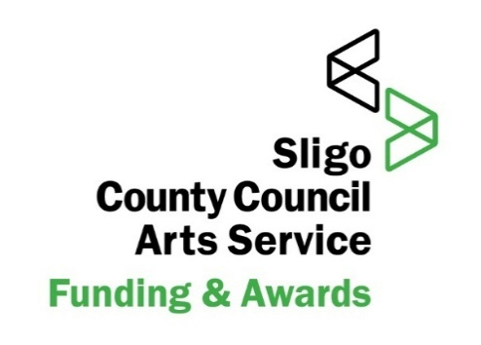
UNHEARD VOICE AWARD APPLICATION FORM
SLIGO ARTS SERVICE IN PARTNERSHIP WITH THE ARTS COUNCIL
Award: €2,000 + 4 one-to-one mentoring sessions
Closes: 5pm Thursday 23rd October 2025
Application process: Email only arts@sligococo.ie

Section 1: PERSONAL INFORMATION
Full Name:
Address:
Telephone:
Email:
Date of Birth (optional):
Preferred Pronouns (optional):

Section 2: ABOUT YOU
2.1 Based on definitions below, please X what stage of your career you are at:
Emerging Mid-career
Emerging Writer:
- Has begun to develop their professional writing practice but has limited publication or production experience.
- Has demonstrated commitment to writing through completed work, participation in workshops, courses, or readings.
May have some publications (e.g. in journals, anthologies, online platforms) but no full-length book yet published with a recognised publisher.
- Is not yet earning a significant portion of their income from writing.
- Is at a stage of developing craft, building networks, and seeking professional guidance or mentorship.

Mid-Career Writer:
- Has established a publishing or production record and is working to consolidate or extend their career.
- Has at least one full-length work (novel, short story collection, poetry collection, or equivalent) published or under contract with a recognised, independent publisher.
Demonstrates an ongoing writing practice and engagement with the literary community.
- May have received previous supports (residencies, bursaries, mentoring) and is now seeking to develop their audience, sustainability, or craft at a deeper level.
- Often in transition between “emerging” and “established,” focusing on advancing their career.

2.2 Please describe your background and / or the community you identify with as per the award criteria:

2.3 Tell us about your writing journey so far - how long you are writing, forms you work in, courses, readings, publications, creative milestones etc

Section 3: YOUR WRITING & VISION
3.1 Briefly describe your current writing practice - themes, forms, ideas & how you approach your writing:

3.2 What project(s) or areas of development would you like to focus on through this award and mentorship?
1
2
3
4
5

3.3 How would this award:
(a) support your development

(b) contribute to increasing diversity & inclusivity in Irish writing?

3.3 What kind of mentor or support would be most helpful to you? e.g. someone with experience in your genre, expertise in publishing, someone who understands cultural context etc:

3.4 If you have received any writing bursaries or awards and/or participated in any residencies, please give details below:
1
2
3
4
5

3.5 Is there anything else you would like to share about your circumstances as a writer?

Section 4: DECLARATION
I confirm that:
- I am based in Sligo Ireland
- I identify as a member of an under-represented community in Irish literature as have demonstrated this through my application
- The information provided is true and accurate to the best of my knowledge.

Signature:
Date:

Section 5: HOW TO SUBMIT
How to Apply:
- Complete this application form
- Alternative Application Format: Audio Submission (We Transfer)
- Submit your application (paper OR audio) to the email address: arts@sligococo.ie
- Email 1 sample of your work along with your application whether written or audio – without this your application will not be accepted

Paper Application Forms: via email at: arts@sligococo.ie
Audio Applications: via We Transfer (see instructions below)
ALL APPLICATIONS MUST ALSO INCLUDE:
- a sample of your writing as a separate PDF to support your application.
Up to 10 pages may be submitted. Your application will be deemed incomplete without a writing sample

Section 6: WRITING SAMPLE
Please list here:
Title of Work:
Form (fiction, poetry, theatre, screenwriting, non-fiction):
Length:

AUDIO SUBMISSIONS:

Applicants may choose to submit a short audio recording instead of a written application.
In your recording (5–7 minutes), please refer to the written application and answer the questions in it. The audio MUST include:

- Your name and contact details (telephone, address & email)
- Your background and the community you identify with
- Your writing journey so far
- What you hope to achieve through the award
- How the award and mentorship would support your development
- An audio reading of a piece of work (include title & background) no more than 3 minutes in duration OR A PDF SAMPLE OF YOUR WORK VIA WE TRANSFER

How to record & submit an audio application:

- You can record on your phone, computer, or any device.

- Save your file as .mp3, .m4a, .wav, or .mp4.

Submitting via WeTransfer:

- Go to wetransfer.com and click “Send a file.”
- Add your audio file.
- Enter arts@sligococo.ie as the recipient and your own email to receive confirmation.
- Include a short message with your name and note that this is your Unheard Voice Award application.
- Click “Transfer” and wait for the confirmation email.

Tip: Keep your recording under 5–7 minutes and label the file clearly (e.g., Jane_Doe_UVA_Audio.mp3).

Contact arts@sligococo.ie if you need help submitting.

Closes: 5pm Thursday 23rd October 2025

